**CHAPTER 10**

**POWER SUPPLY**

**10.1 INTRODUCTION**

IC regulators are versatile and relatively inexpensive and are available with features such as current/voltage boosting, internal short circuit current limiting, thermal shutdown and floating operation for high voltage applications. The regulated circuit is used to maintain constant output level. The integrated circuit regulator, sometimes called the three terminal regulators contains the circuitry for reference source error amplitude control device and overload protection all in a single IC chip. They are connected between output of a filter and input to the load.

**10.2 OVERVIEW**

It provides the necessary power needed. The system requires a regulated +5v supply for the semiconductors and a +12v unregulated supply for the relay. These can be delivered from the 230v domestic supply. Before applying this to the system we must step down this high voltage to an appropriate value. After that it should be rectified. This will provide a unidirectional current. To achieve a +5v DC we should regulate this.

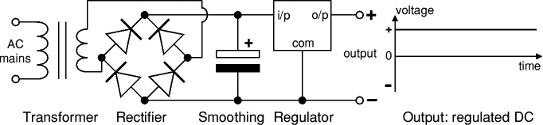

[Transformer](http://www.kpsec.freeuk.com/powersup.htm#transformer) - steps down high voltage AC mains to low voltage AC.

Rectifier - converts AC to DC, but the DC output is varying.

Smoothing - smoothes the DC from varying greatly to a small ripple. Regulator - eliminates ripple by setting DC output to a fixed voltage.

**LM7805**

The 78xx series consist of three terminal +ve voltage regulators. With adequate heat sinking they can deliver output current in excess of 1A. For proper operation, there should be a common ground between the input and output voltage. The capacitor C2 is used to improve the transient response of the filter.

As per the Indian standards, the supply through the mains is 230 volts, 50 hertz ac. For this project, the power requirements are +5V and +12V +9V dc voltage levels. In order to obtain the required output from the voltage regulators like 7812 etc, a minimum of 14.5V dc input is required.

By considering the current requirements of the various ICs and the loading effects of the different current drawing elements used in this project, the total current requirement was found to be around 1 amp.

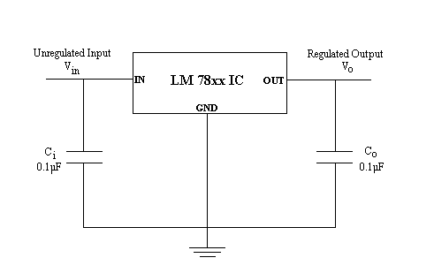

The capacitor Ci is connected to the input of the regulator to eliminate inductive effect due to long distribution leads. The output capacitor Co improves the transient response.

**10.3 CONCLUSION**

IC regulators are versatile and relatively inexpensive and are available with features such as current/voltage boosting, internal short circuit current limiting, thermal shutdown and floating operation for high voltage applications. The regulated circuit is used to maintain constant output level. The integrated circuit regulator, sometimes called the three terminal regulators contains the circuitry for reference source error amplitude control device and overload protection all in a single IC chip. They are connected between output of a filter and input to the load.